**Note to users: items shown in red indicated edits / selections that need to be made to tailor the specification for the application.**

Retain and edit "Delegated-Design Submittal" Paragraph 1.E below if design services have been delegated to the contractor. The delegated design may be completed entirely by the contractor or may also involve the equipment manufacturer. Typically, the contractor would be responsible for the means and methods to attach anchors and guides to the structure, and field-fabrication of anchors. Expansion joint manufacturers may be involved in the piping analysis and selection of expansion joints and placement of anchors and guides.

# Internally Pressurized Expansion Joint:



Product Specifications

1. General
2. Provide expansion joints as indicated on the contract drawings or as required to accommodate any axial thermal expansion or contraction of the piping system.
3. Expansion joints to be of the packless, internally pressurized bellows type.
4. All materials of construction, pressure ratings, and end fittings shall be appropriate for the application. Guiding and anchoring per EJMA recommendations and guidelines
5. Delegated-Design Submittal: Provide analysis signed and sealed by a qualified professional engineer. Submittal shall include [edit as required for project]:
   1. Design Calculations: Calculate requirements for thermal expansion of piping systems and criteria for selecting and designing expansion joints, hard-pipe loops, and swing connections.
   2. Schedule and drawings: Indicate type, manufacturer's number, size, material, pressure rating, end connections, and locations for each expansion joint, anchor and guide.
   3. Anchor Details: Detail fabrication of each anchor indicated. Show dimensions, methods of assembly, and attachment to building structure.
   4. Alignment Guide Details: Detail field assembly and attachment to building structure.

2. Products

A. Manufacturer: Expansion joints shall be **“MNLC”** as manufactured by The Metraflex Company®, Chicago, IL.

B. Expansion joints shall conform to ASTM F-2934

C. Performance: Expansion joints shall be pressure rated for:

a. 50 PSI at 500⁰ F

b. 150 PSI at 500⁰ F.

c. 300 PSI at 500⁰ F

D. Bellows shall be

a. Short style to satisfy project requirements.

b. Long style to satisfy project requirements.

E. End fittings shall be

* 1. Raised Face Flange.
     1. 150 lb. class.
     2. 300 lb. class.
  2. Weld End.
     1. Sch 40 / Standard Weight.
     2. Sch 80 / extra strong.
  3. Grooved end.
  4. As specified.

G. Bellows: Bellows shall be low corrugation style manufactured from T304 stainless steel. The number of corrugations and overall length of the expansion joints shall be determined by the thermal expansion requirements, system design engineer, and manufacturer’s recommendations based on EJMA (Expansion Joint Manufacturers Association) standards.

H. Tie Rods shall be installed when piping system is not anchored or when required on project drawings

I. Liners: Bellows shall be equipped with liners when the velocity exceeds the below values or is used in an abrasive application.

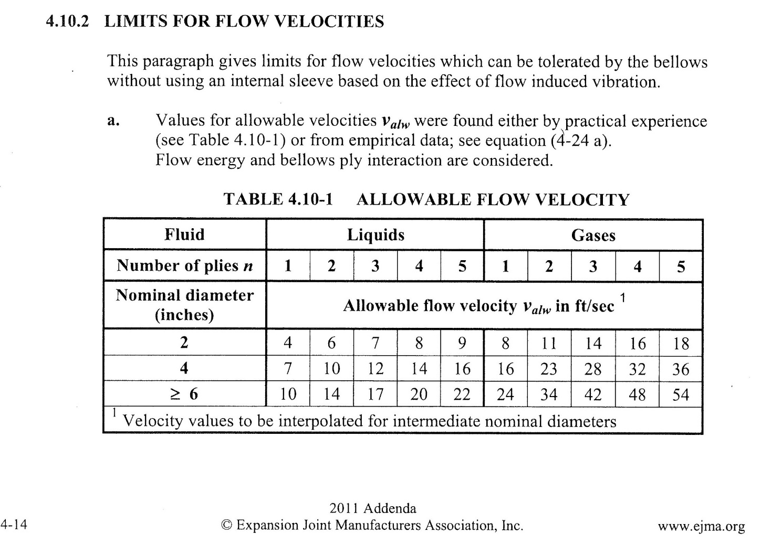

J. Covers shall be used bellows is subject to mechanical damage.

3. Execution

A. Guiding: Pipe guides adjacent to the expansion joint shall be in accordance to EJMA guidelines based on design pressure and line size. (Alternative guiding may be acceptable after design review by manufacturer, calculations with qualified design professional’s signature and seal shall be submitted.)

B. Installation shall be in accordance with manufacturers printed instructions.