# 

Product Specifications

**Note to users: items shown in red indicated edits / selections that need to be made to tailor the specification for the application.**

Retain and edit "Delegated-Design Submittal" Paragraph 1.E below if design services have been delegated to the contractor. The delegated design may be completed entirely by the contractor or may also involve the equipment manufacturer. Typically, the contractor would be responsible for the means and methods to attach anchors and guides to the structure, and field-fabrication of anchors. Expansion joint manufacturers may be involved in the piping analysis and selection of expansion joints and placement of anchors and guides.

# Internally Pressurized Ring Controlled Expansion Joint: Style MC

1. General:
2. Provide expansion joints as indicated on the contract drawings or as required to accommodate any axial thermal expansion or contraction of the piping system.
3. Expansion joints to be of the packless, internally pressurized type.
4. All materials of construction, pressure ratings, and end fittings shall be appropriate for the application. Guiding and anchoring per EJMA recommendations and guidelines

2. Products

A. Manufacturer: Expansion joints shall be **“MC”** as manufactured by The Metraflex Company®, Chicago, IL.

B. Expansion joints shall conform to ASTM F-2934

C. Performance: Expansion joints shall be pressure rated for

* 1. 150 lb. class.
  2. 300 lb. class.

D. Bellows shall be ring controlled hydrostatically formed high corrugation single ply type 304 stainless steel.

E. Control / equalizing rings shall be cast iron and shall provide bellows reinforcement and shall prevent over compression.

F. End fittings shall be

* 1. Raised Face Flange.
  2. Weld End.
     1. Sch 40 / Standard Weight.
     2. Sch 80 / extra strong.
  3. Grooved end.
  4. As specified

G. Bellows: The number of corrugations and overall length of the expansion joints shall be determined by the thermal expansion requirements, system design engineer, and manufacturer’s recommendations based on EJMA (Expansion Joint Manufacturers Association) standards.

H. Tie Rods shall be installed when piping system is not anchored or when required on project drawings

I. Liners: Bellows shall be equipped with liners when the velocity exceeds the below values, or when used in abrasive applications.

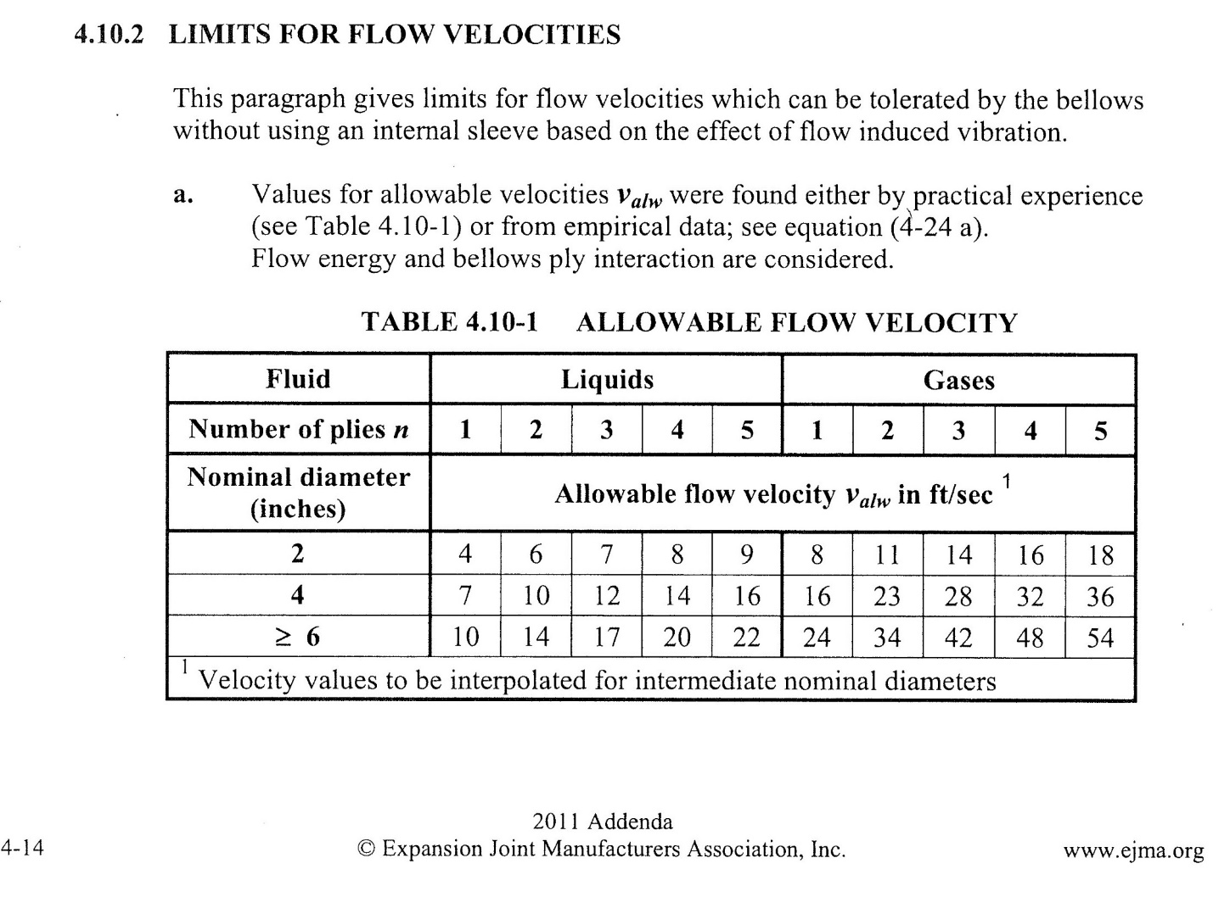

J. Covers shall be used bellows is subject to mechanical damage.

3. Execution

A. Guiding: Pipe guides adjacent to the expansion joint shall be in accordance to EJMA guidelines based on design pressure and line size. (Alternative guiding may be acceptable after design review by manufacturer, calculations with qualified design professional’s signature and seal shall be submitted.)

B. Installation shall be in accordance to manufacturers printed instructions.